Assessing linearity of the logit model

1). Build a logistic model that predicts whether a student has pulled a “AllNighter”, based on their “WeekdaySleep”. Comment on the linearity of the model using a emplogitplot.

library(readr)  
library(Stat2Data)  
Sleep <- read_csv("https://raw.githubusercontent.com/JA-McLean/STOR455/master/data/SleepStudy.csv")

## Rows: 253 Columns: 27

## -- Column specification --------------------------------------------------------  
## Delimiter: ","  
## chr (5): LarkOwl, DepressionStatus, AnxietyStatus, Stress, AlcoholUse  
## dbl (22): Gender, ClassYear, NumEarlyClass, EarlyClass, GPA, ClassesMissed, ...

##   
## i Use `spec()` to retrieve the full column specification for this data.  
## i Specify the column types or set `show_col_types = FALSE` to quiet this message.

All_Nighter = glm(AllNighter~WeekdaySleep, family=binomial, data=Sleep)  
summary(All_Nighter)

##   
## Call:  
## glm(formula = AllNighter ~ WeekdaySleep, family = binomial, data = Sleep)  
##   
## Deviance Residuals:   
## Min 1Q Median 3Q Max   
## -1.5137 -0.5438 -0.4543 -0.3618 2.5528   
##   
## Coefficients:  
## Estimate Std. Error z value Pr(>|z|)   
## (Intercept) 2.4767 1.1789 2.101 0.035656 *   
## WeekdaySleep -0.5713 0.1579 -3.617 0.000298 ***  
## ---  
## Signif. codes: 0 '***' 0.001 '**' 0.01 '*' 0.05 '.' 0.1 ' ' 1  
##   
## (Dispersion parameter for binomial family taken to be 1)  
##   
## Null deviance: 199.69 on 252 degrees of freedom  
## Residual deviance: 185.78 on 251 degrees of freedom  
## AIC: 189.78  
##   
## Number of Fisher Scoring iterations: 5

emplogitplot1(AllNighter~WeekdaySleep, data=Sleep, ngroups=10)

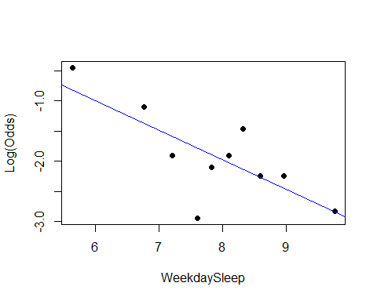 As we can see in our summary output, our WeekdaySleep term looks significant, and looking at the plot it seems as if the points follow a linear pattern, as there is no clear curve.